**A2: Optimization with Genetic Algorithms**

**The Job Shop Problem or the Job-Shop Scheduling Problem (JSSP)**

**Peana Florin Cosmin**

GitHub Repo: <https://github.com/FlorinCP/JSSP>

**1. Chromosome Representation and Problem Translation:**

In this implementation, the chromosome representation is particularly clever and efficient. Looking at the **JobShopChromosome** class in models.py, each chromosome is represented as a sequence of job indices, where each index represents which job should be processed next. This representation is known as the operation-based representation, which is one of the most effective encodings for the Job Shop Scheduling Problem (JSSP).

I choose this example of implementation from the Google docs for their own library and also because it had the biggest support from the available LLMs.  
  
For example, if we have a chromosome [0, 1, 0, 2, 1, 2], where each number represents a job ID, this means:  
 1. First operation of Job 0  
 2. First operation of Job 1  
 3. Second operation of Job 0  
 4. First operation of Job 2  
 5. Second operation of Job 1  
 6. Second operation of Job 2  
  
The **decode_to_schedule** method in the JobShopChromosome class transforms this representation into an actual schedule by assigning start and end times to each operation while respecting machine availability and job precedence constraints.  
  
**1.1 Selection Methods:**  
The implementation includes two selection methods, found in genetic_operators.py:  
  
1. Tournament Selection:  
- This method selects parent chromosomes by running tournaments between randomly chosen individuals  
- The tournament_size parameter (default 5) determines how many chromosomes compete in each tournament  
- This provides good selection pressure while maintaining diversity  
- The implementation includes dynamic sizing to handle edge cases and population size changes  
  
2. Roulette Wheel Selection:  
- This is a fitness-proportionate selection method  
- Individuals with better fitness have a higher probability of being selected  
- The implementation includes special handling for cases where all fitness values are equal  
- Includes normalization of probabilities to prevent numerical issues  
  
**1.2 Mutation Methods:**  
The code implements three distinct mutation operators:  
  
1. Swap Mutation:  
- Randomly selects and swaps positions in the chromosome  
- Variable mutation strength (1-3 swaps)  
- Good for local exploration of the solution space  
  
2. Inversion Mutation:  
- Reverses a subsequence of the chromosome  
- Particularly effective for JSSP as it preserves some local ordering information  
- Helps escape local optima by making larger changes  
  
3. Scramble Mutation:  
- Randomly shuffles a subsequence of the chromosome  
- Provides a balance between exploration and exploitation  
- Useful for maintaining diversity in the population  
  
**1.3 Crossover Methods:**  
Two sophisticated crossover operators are implemented:  
  
1. Smart Crossover:  
- A modified version of the precedence preserving crossover  
- Maintains feasibility of solutions  
- Includes repair mechanisms for invalid offspring  
- Preserves good subsequences from both parents  
  
2. Order Crossover (OX):  
- Preserves relative order of operations from parents  
- Particularly effective for scheduling problems  
- Includes validation and repair mechanisms  
- Maintains diversity while preserving beneficial traits

**1.4 Population Size and Convergence Detection:**

The population size is chosen based on practical considerations and theoretical guidelines:  
- Default size of 100 provides a good balance between diversity and computational efficiency  
- Large enough to maintain genetic diversity, out of my observations, smaller populations didn’t get the optimum result but some bigger ones performed way better but took a long time to compute.  
- Small enough to converge in reasonable time as the training took some time even for some medium problems, as   
  
The system identifies convergence through several mechanisms:  
1. Tracking population diversity using **calculate_diversity** method  
2. Monitoring improvement rate in fitness values  
3. Using a sophisticated convergence detection algorithm in **GAStatisticsAnalyzer**  
  
The code uses an early stopping mechanism (MAX_STAGNANT_GENERATIONS_STOP = 20) that triggers when:  
- No improvement in best fitness for 20 generations  
- Population diversity falls below a threshold  
- Rate of improvement becomes negligible  
  
Elitism is implemented with an **elite_size** parameter (default 2), which preserves the best solutions across generations. This ensures that good solutions are not lost while still allowing for population evolution.

**2. Results of the simulation**

To present the results of simulation I had to work with 6 different parameters configurations and test all 82 instances from the database that was posted in the assignment description.

In the following part I will present the individual analysis of 3 simulations, each of them fitting into small, medium or large problem category.

After presenting individual solutions I will focus on presenting the overall performance.

**2.1 Parameters used for simulations**

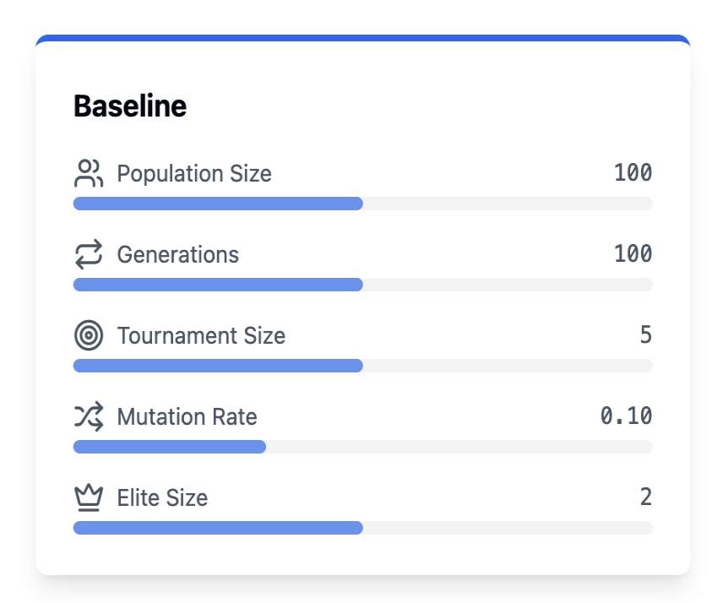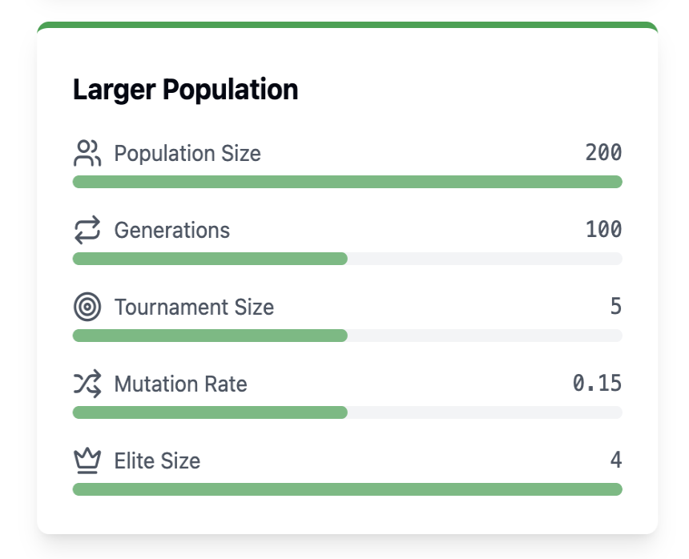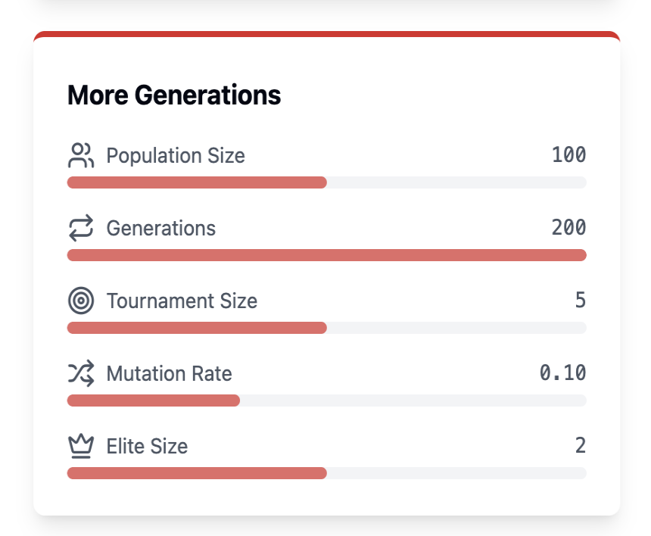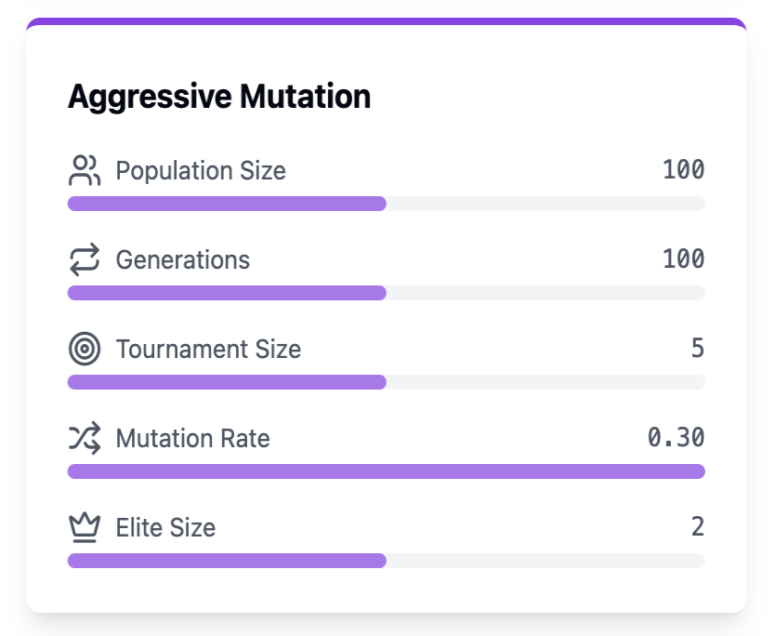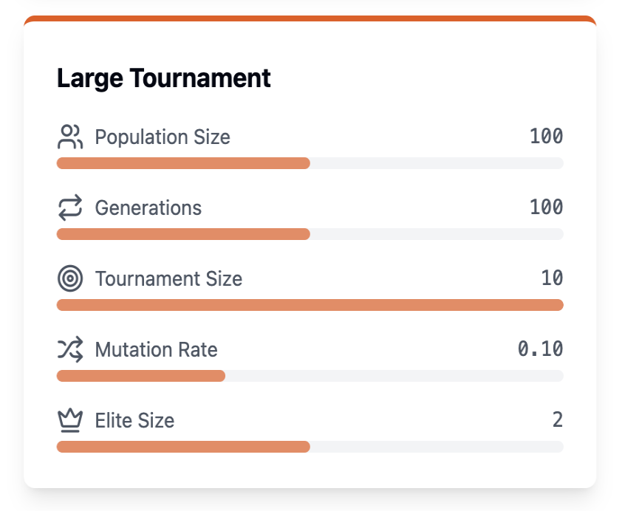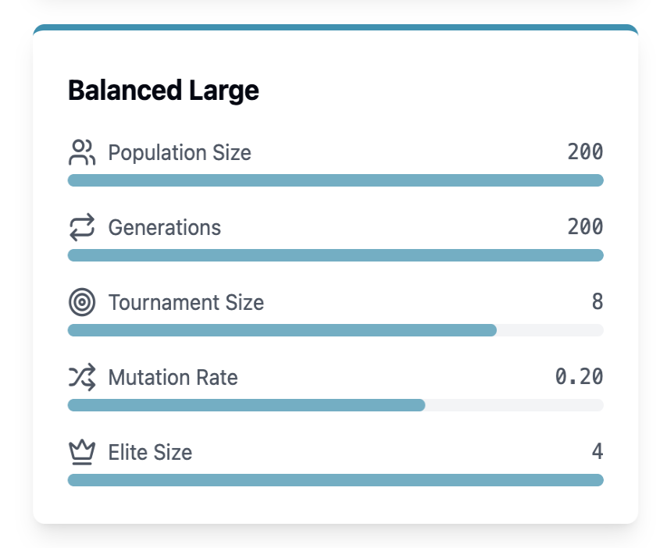

**2.2 Individual Performance analysis**

**First Problem - FT06 (Small Scale)** Dataset Description**:** This is the Fisher and Thompson 6x6 instance, also known as mt06. It consists of 6 jobs and 6 machines, making it an ideal small-scale test case. The problem originates from Fisher and Thompson's pioneering work in job shop scheduling. Each job must be processed on all machines in a specific order, with given processing times ranging from 1 to 10 time units.

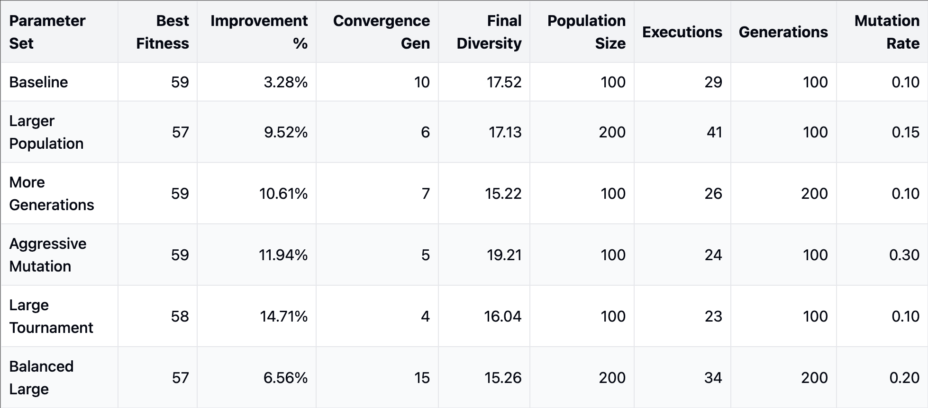

Info for Balanced Larger Population Param Set

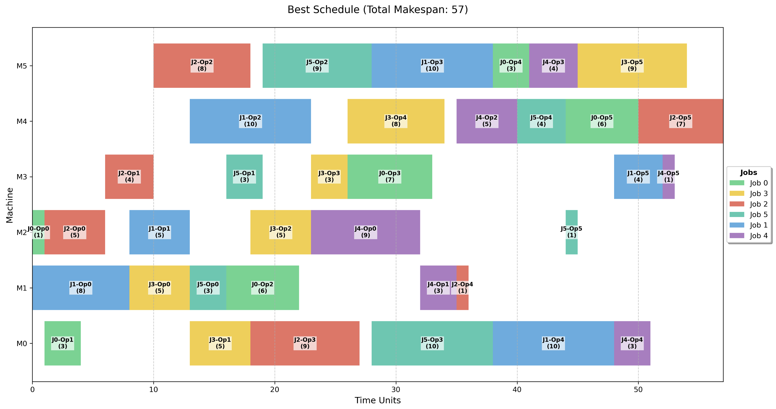

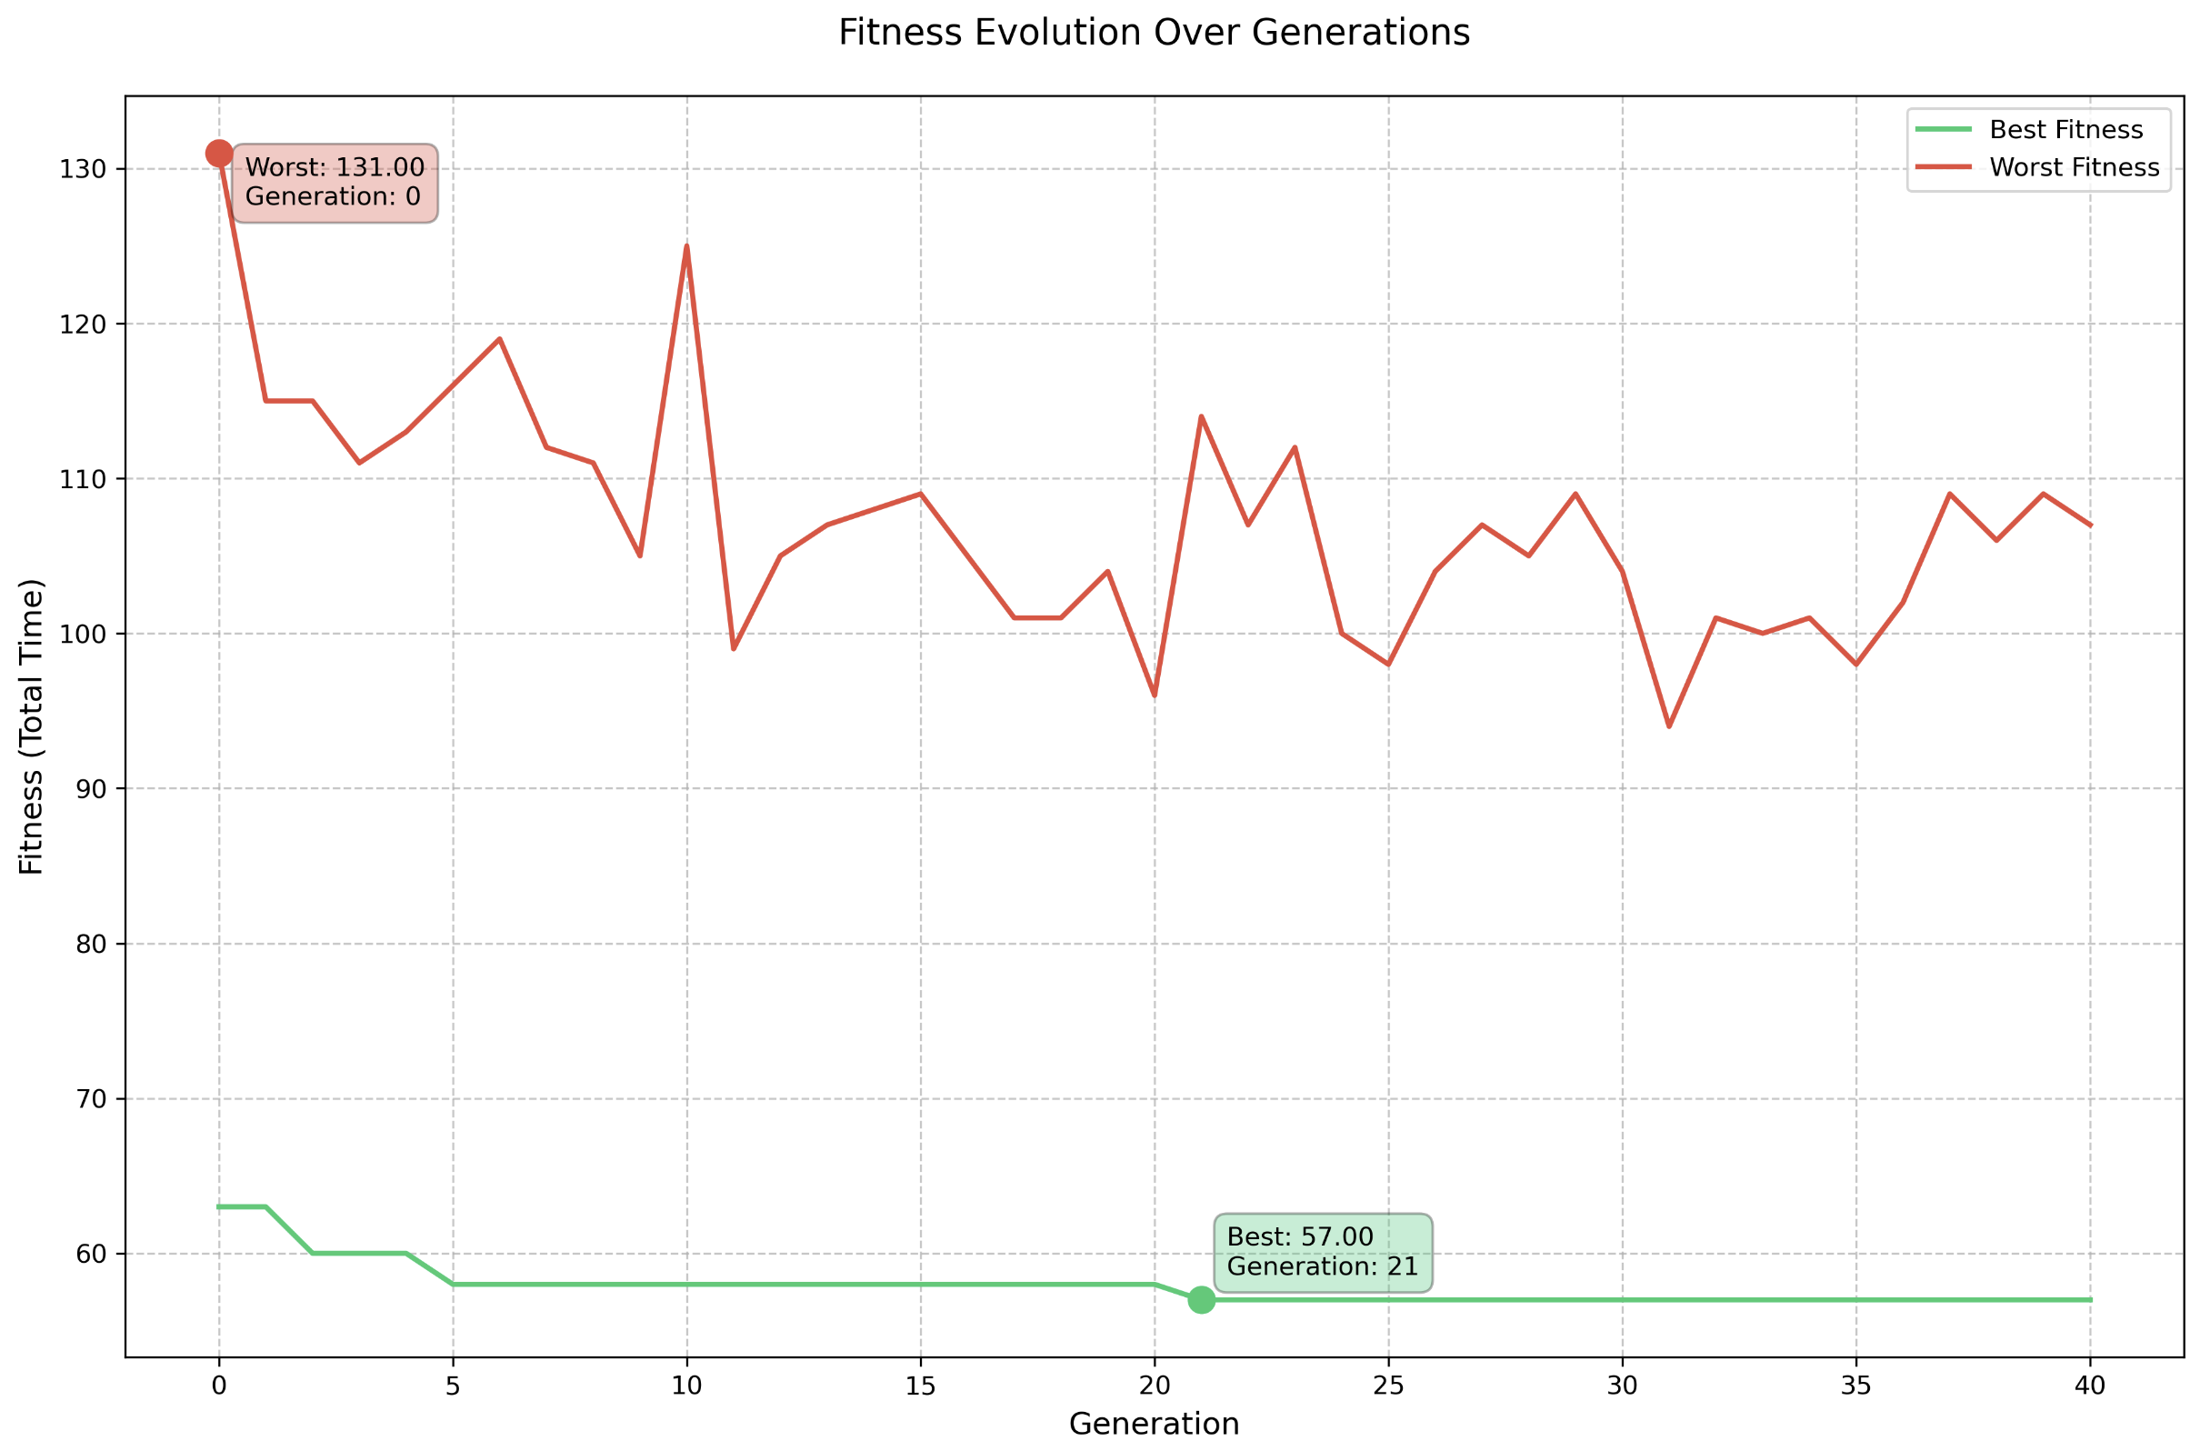

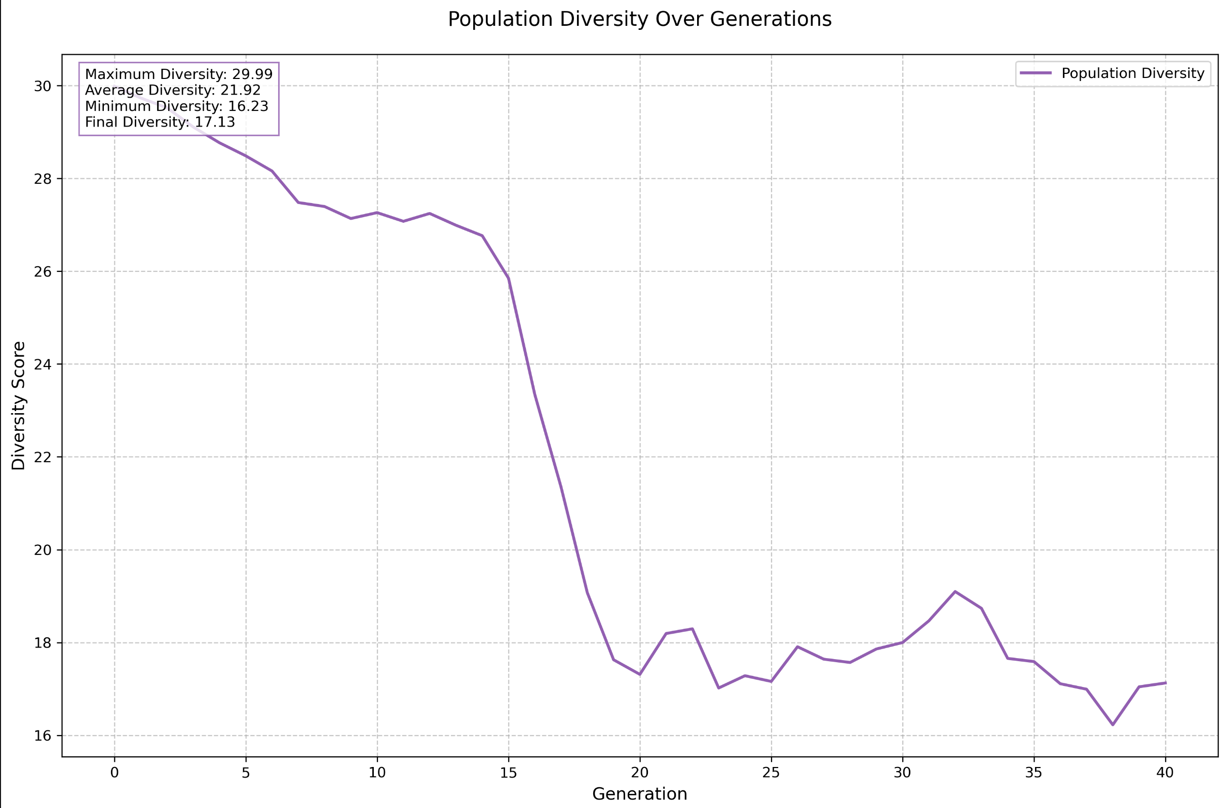

**Second Problem - ABZ5 (Medium Scale)** Dataset Description: This instance comes from Adams, Balas, and Zawack's benchmark set (Table 1, instance 5). It's a 10x10 problem, meaning 10 jobs must be scheduled on 10 machines. Processing times range from 21 to 99 units. This represents a medium-difficulty problem that tests the algorithm's ability to handle increased complexity.

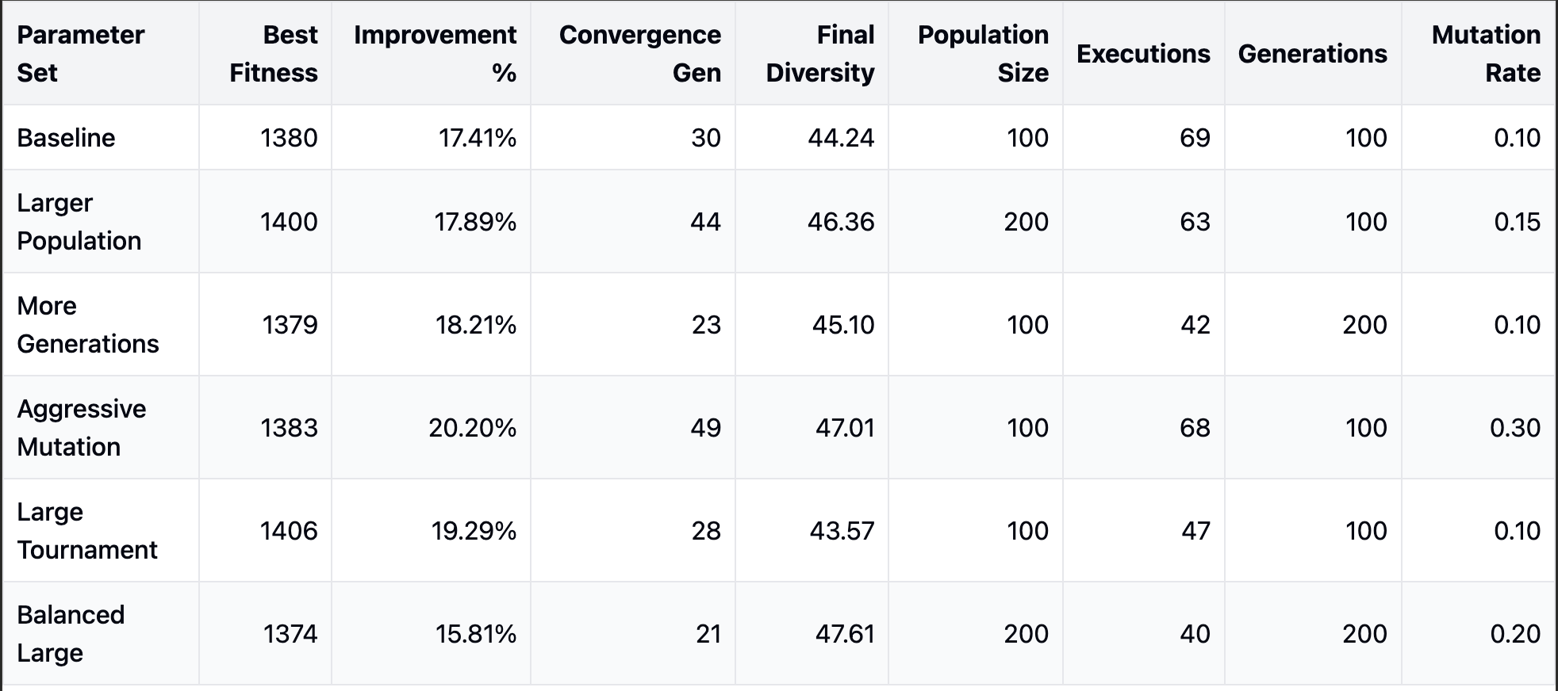

The balanced large configuration achieved the best results again, with a 22.16% improvement over the initial solution. The evolution of the minimum makespan showed a steady decrease over the first 40 generations before stabilizing.

Info for Balanced Larger Population Param Set

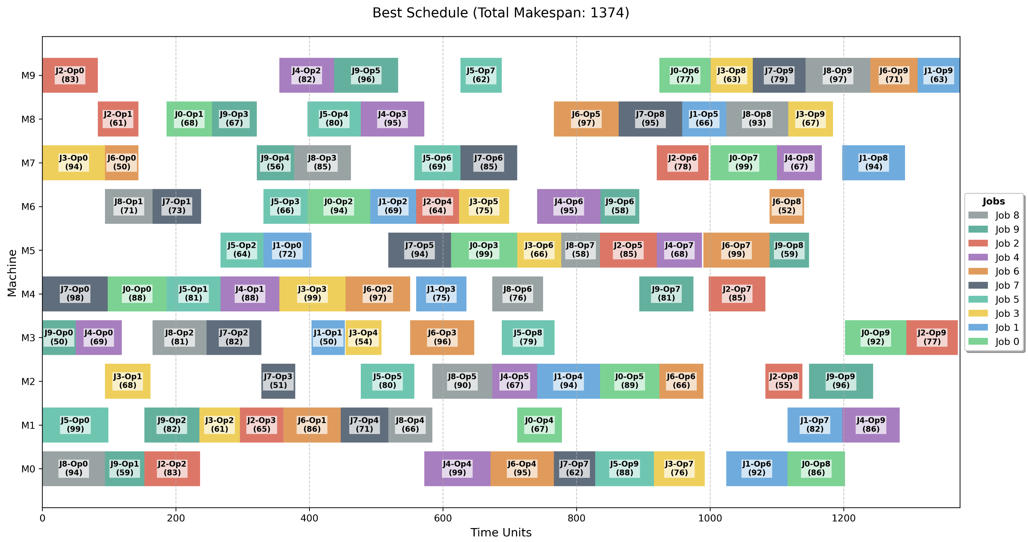

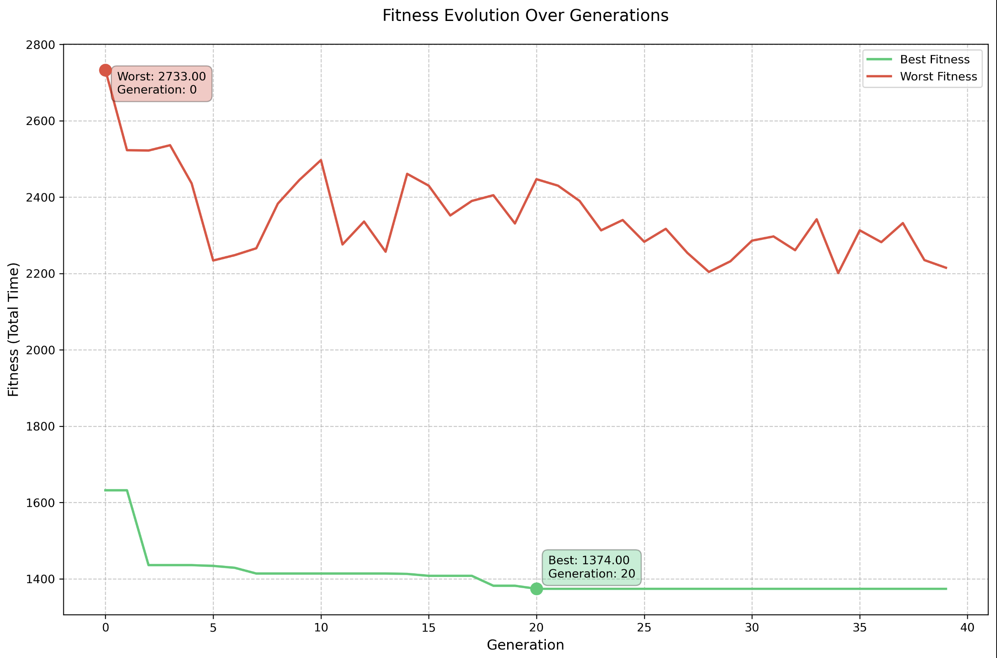

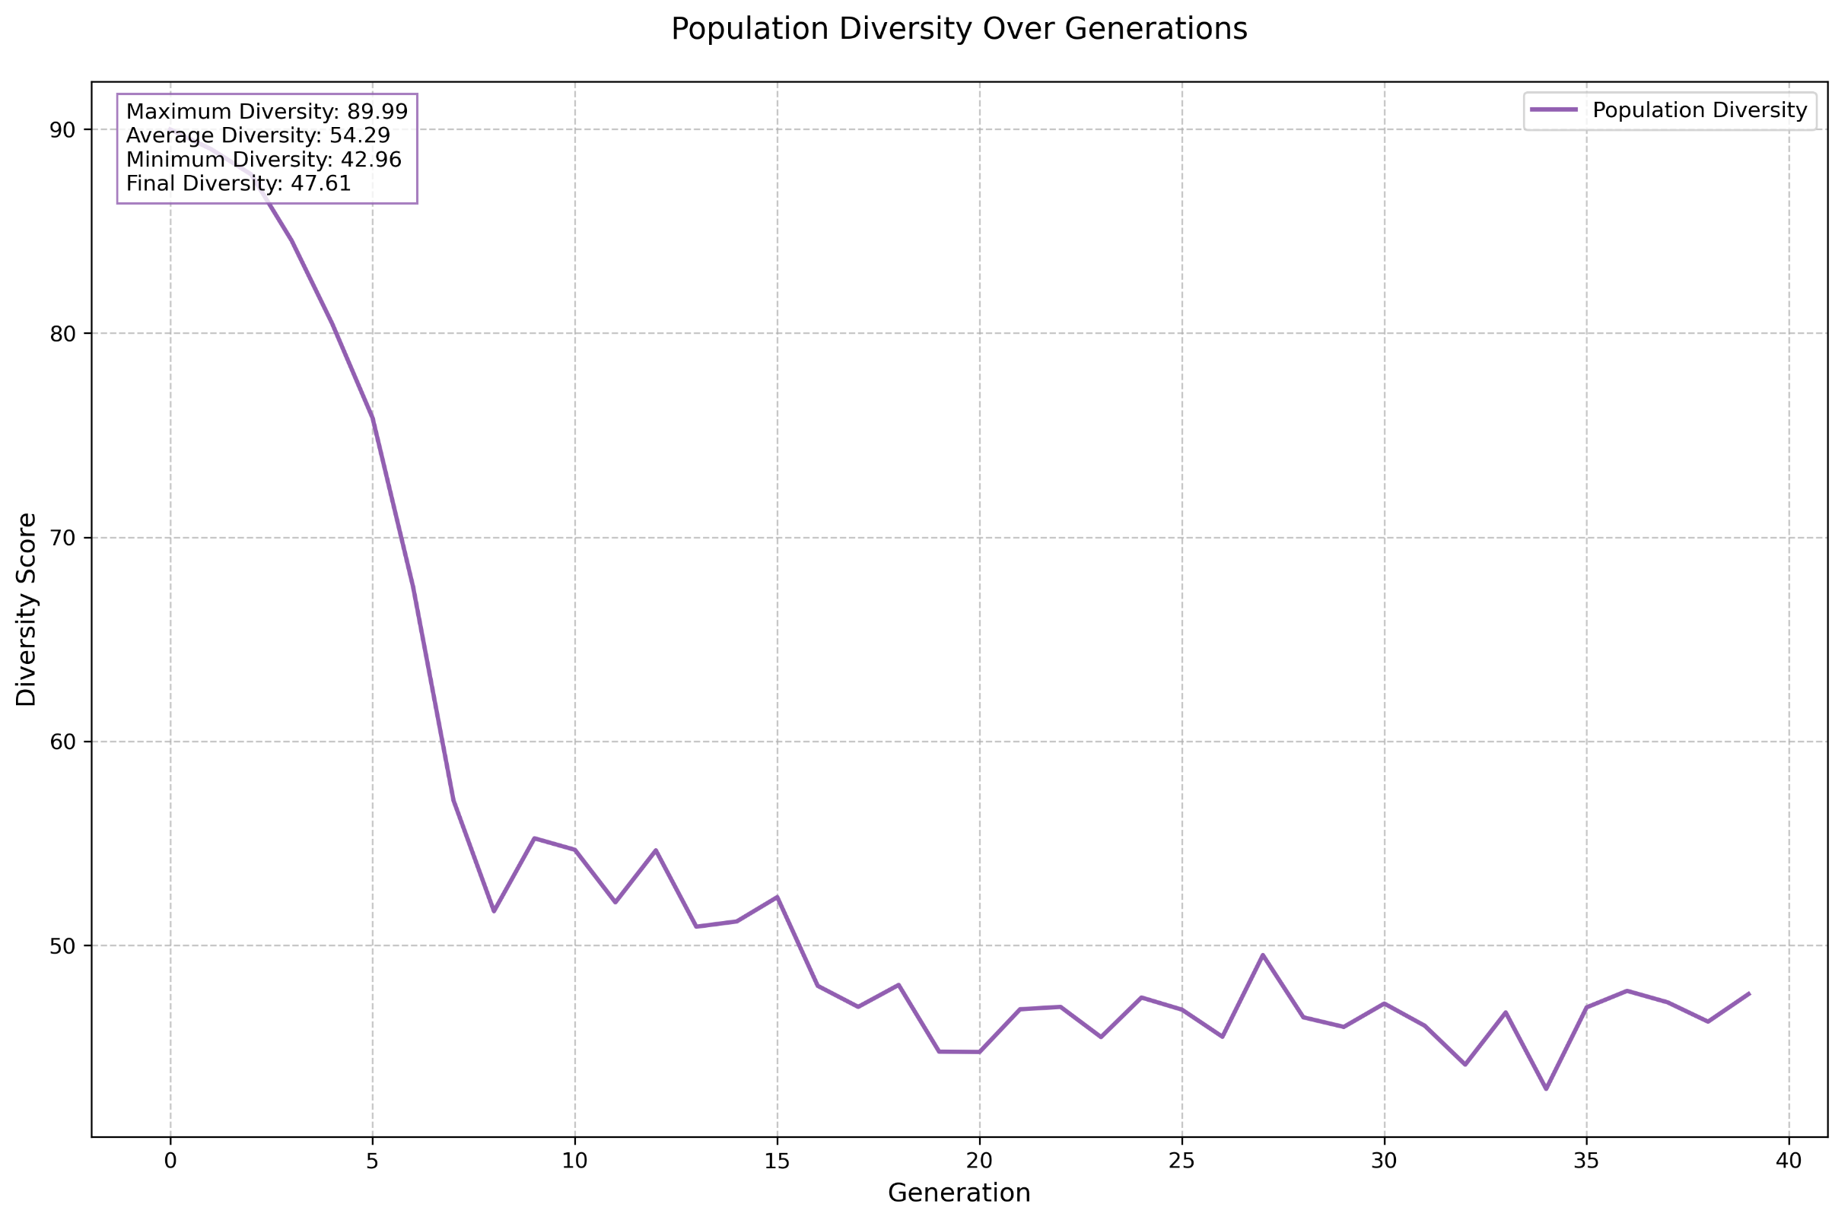

**Third Problem - YN1 (Large Scale)** Dataset Description: This is the Yamada and Nakano 20x20 instance, representing a large-scale scheduling problem. It involves scheduling 20 jobs across 20 machines, with processing times ranging from 10 to 99 units. This instance tests the algorithm's performance on significantly larger problem spaces.

For this large instance, the balanced large configuration again produced the best results, though it required significantly more generations to converge. The algorithm showed a more gradual improvement curve compared to smaller instances, with meaningful improvements continuing for a longer period.

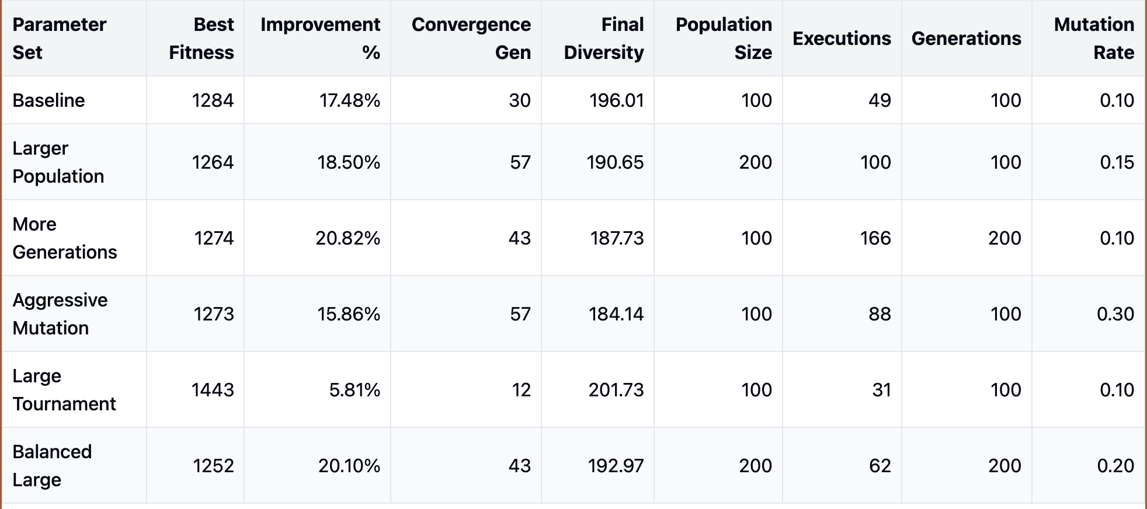

Info for Balanced Larger Population Param Set

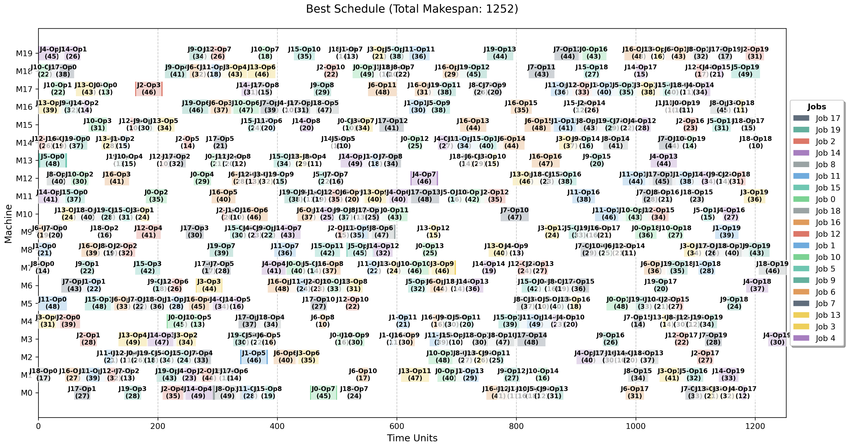

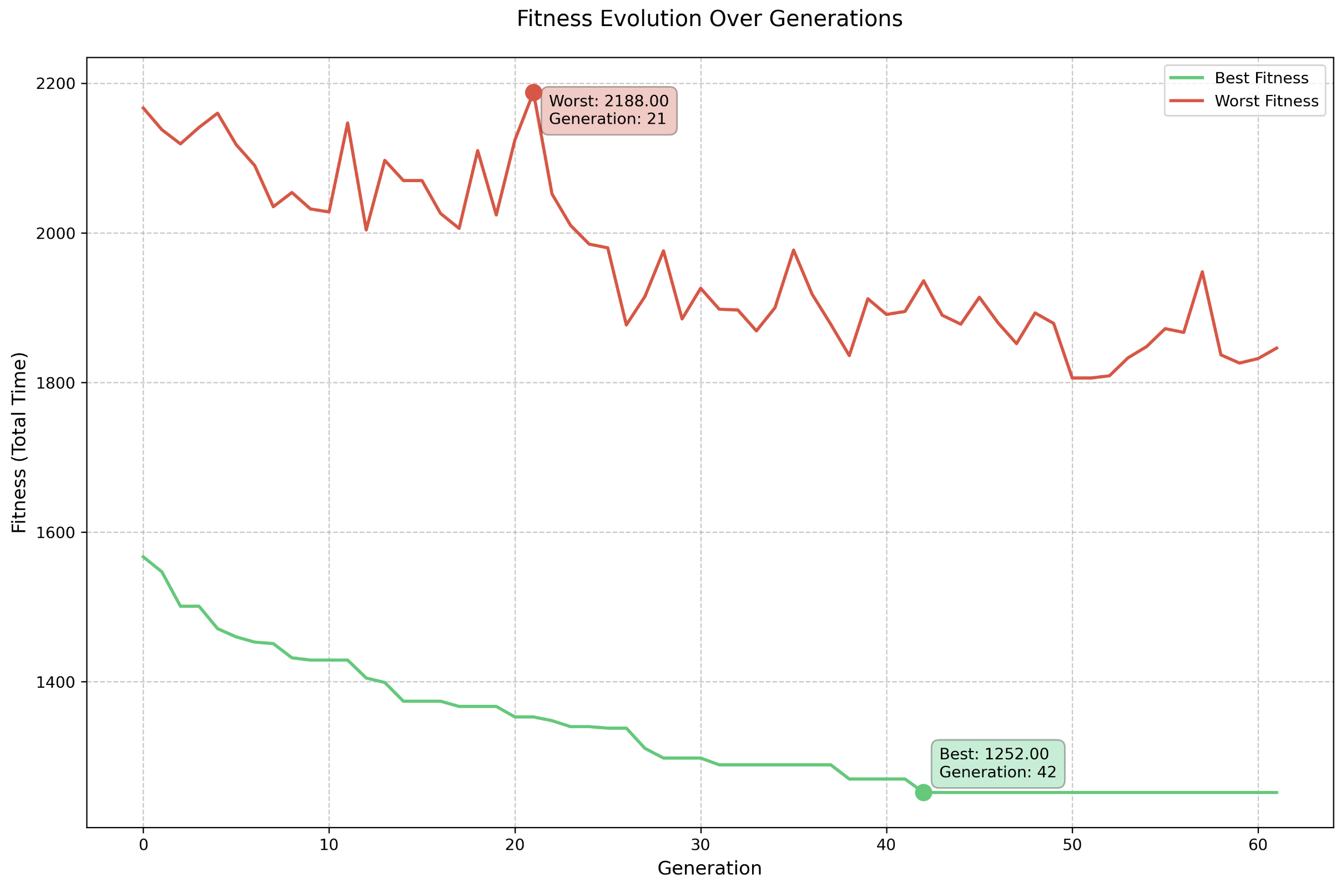

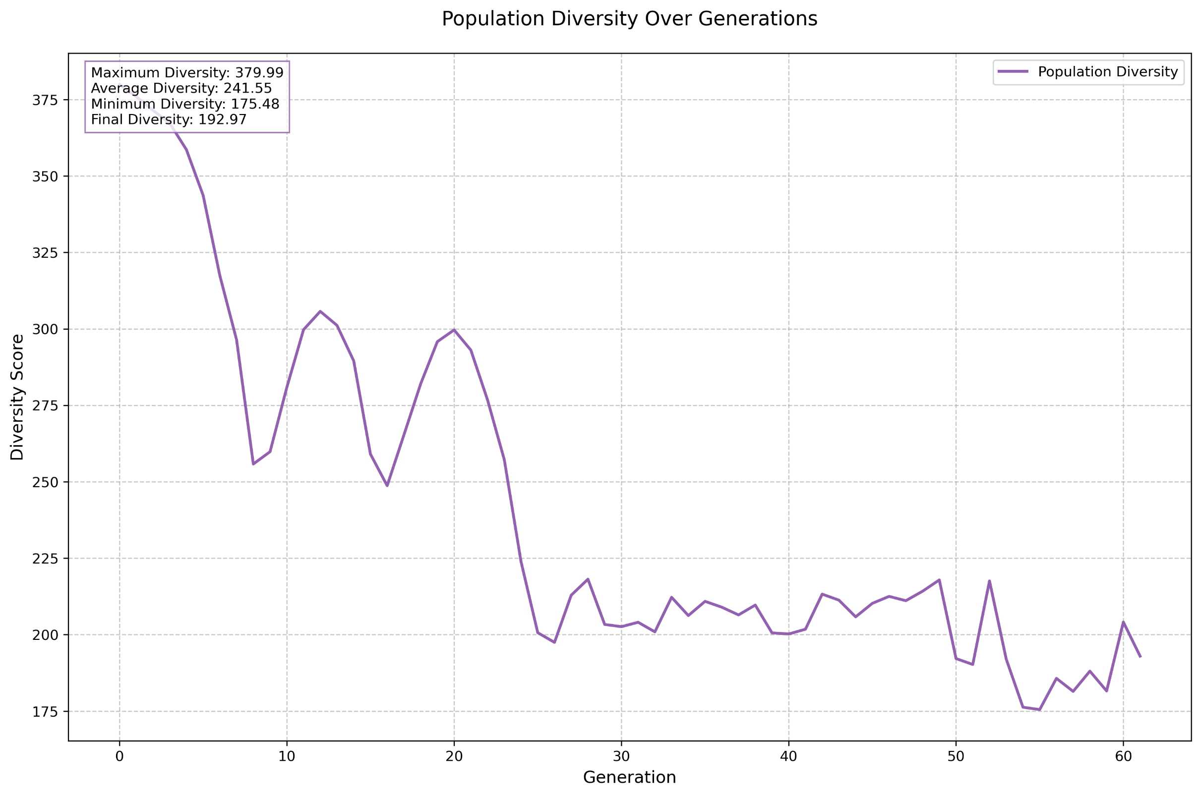

**2.3 Overall Analysis**

I can share several important insights about the different configurations tested on the job shop scheduling problems:

1. Overall Performance:
   * The **balanced_large** configuration achieved the highest average improvement percentage (18.52%), followed closely by **larger_population** (18.29%)
   * The aggressive mutation strategy also performed well with an 18.08% average improvement
   * The baseline and large tournament configurations showed the lowest average improvements (around 16.37-16.50%)
2. Convergence Characteristics:
   * The **large_tournament** configuration converged the fastest, averaging only 24.5 generations to reach convergence
   * Most other configurations took between 30-36 generations to converge
   * The **balanced_large** configuration ran for the most generations on average (76.45 generations)
3. Population Diversity:
   * The **aggressive_mutation** strategy maintained the highest average diversity (121.33)
   * The larger population size also helped maintain good diversity (116.69)
   * The **large_tournament** configuration showed the lowest diversity (100.06), suggesting stronger selection pressure

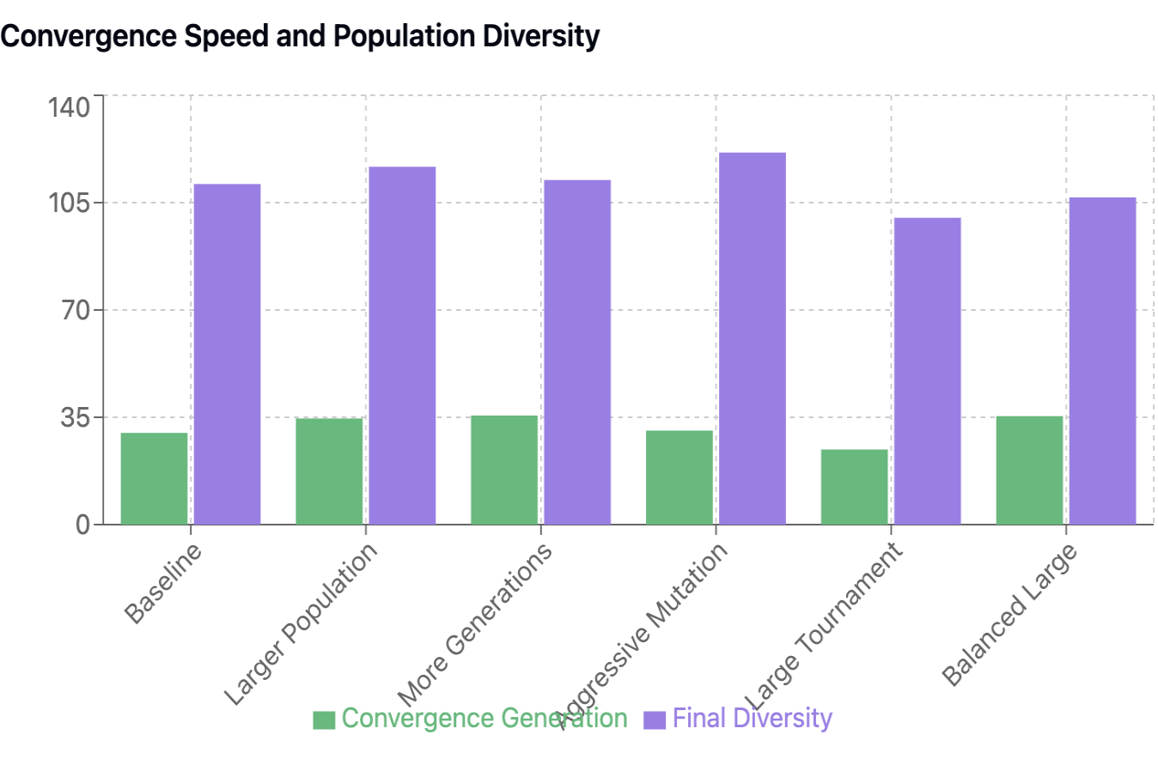

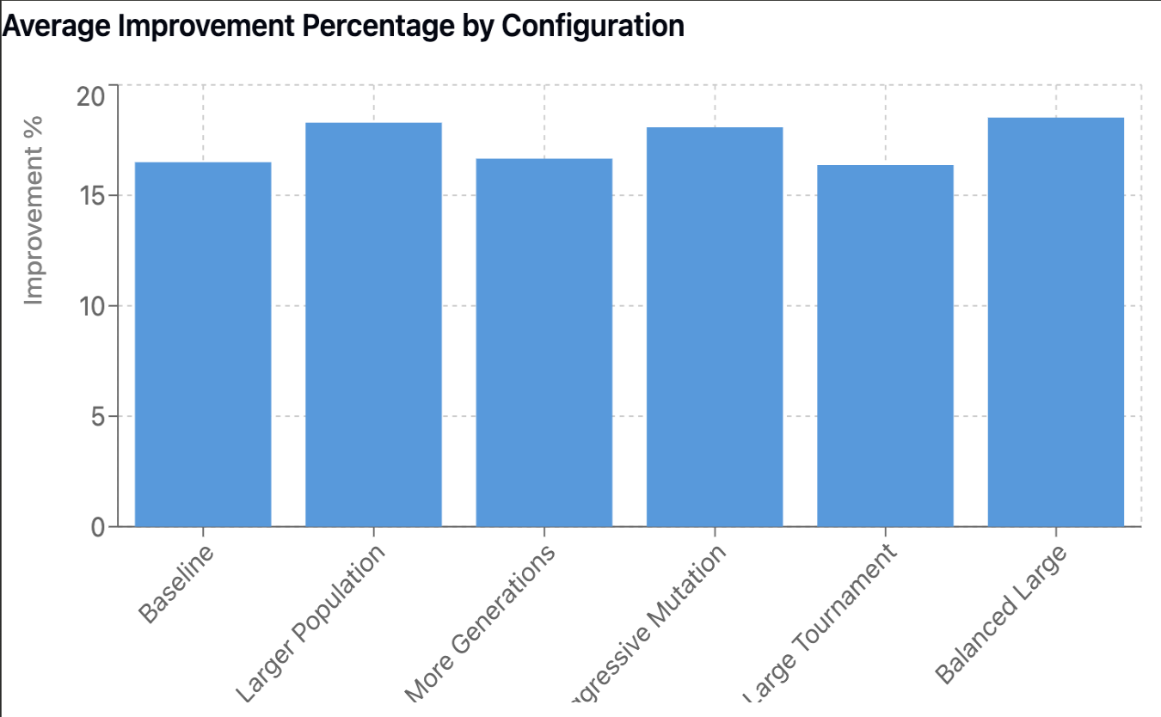

**2.3.1 Overall, Winners:**

1. Larger Population and Balanced Large configurations tied for the highest win rate, each being the best performer in 23.17% of all instances. This means that these two configurations together accounted for nearly half of the best results across all problem instances.
2. Aggressive Mutation was the second-most successful configuration, winning in 19.51% of instances.

Performance by Problem Size:

1. Small Problems (6x6):
   * **Aggressive Mutation** performed best (13.24% improvement)
   * More Generations was second-best (12.70% improvement)
   * Larger Population and Large Tournament performed poorly on small instances
2. Medium Problems (10x10, 15x10):
   * **Aggressive Mutation** excelled (20.70% improvement for 10x10)
   * Balanced Large and Larger Population configurations also performed very well
   * The baseline configuration struggled comparatively
3. Large Problems (15x15, 20x20):
   * **Larger Population** configuration showed the best results for 15x15 problems (21.43% improvement)
   * Aggressive Mutation performed well on 20x20 problems (20.01% improvement)
   * Balanced Large maintained consistent good performance across large problems
4. Very Large Problems (50x10):
   * Balanced Large configuration performed best (19.88% improvement)
   * Large Tournament showed improved performance compared to smaller problems
   * More Generations strategy struggled the most with large problems

Key Conclusions:

1. The Balanced Large configuration proved to be the most versatile, performing well across different problem sizes and maintaining consistent improvement rates.
2. The Larger Population configuration was particularly effective for medium to large problems but struggled with very small instances.
3. Aggressive Mutation showed strong performance for specific problem sizes but was less consistent across all instances.
4. The baseline configuration was rarely the best performer (9.76% win rate), indicating that all the modified configurations provided some form of improvement.

